Data Visualisation
Google Dashboard Key Insights
Summary & Trend Analysis
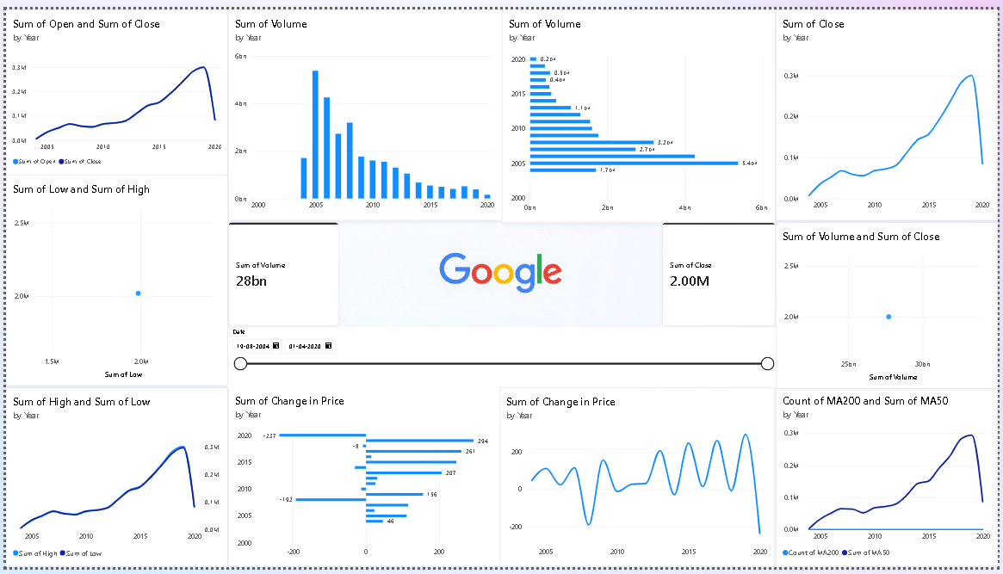

Key Insights
- Closing Price Trend: The yearly closing-price values show noticeable variation over the selected period, indicating changes in Google's stock price over time.
- Open vs Close Comparison: The comparison between Open and Close values shows differences across years, helping identify periods where the stock experienced changes between its opening and closing prices.
- High vs Low Comparison: High values remain above Low values across the yearly comparison, showing the range within which the stock price moved during the trading period.
- Moving Average Comparison: The dashboard compares MA50 and MA200 across years, providing a view of short-term and long-term stock-price movement.
- Trading Volume: Trading volume varies considerably by year. The visualization shows particularly large differences in total volume across the selected years, indicating changing levels of market activity.
- Change in Price: The yearly Change in Price contains both positive and negative values. This indicates that some periods experienced overall price increases while others experienced decreases.
- Price and Volume Relationship: The dashboard includes a comparison of Volume and Close, which can be used to examine how trading activity changes alongside stock-price levels.

Summary
- Overall Observation: The dashboard demonstrates that Google's stock price and trading volume changed substantially over the analyzed period. The comparative visualizations make it easier to identify differences between years, price measures, moving averages, and trading activity.

